Short Exercises

Each of these exercises is designed to test just one or two JavaScript or jQuery skills, and each is designed so it can be done within 5 to 30 minutes. At the start of each exercise, you’ll see an estimated time for the exercise.

Guidelines for doing the short exercises 2

Short 1-1 Test an application and find an error 3

Short 2-1 Modify the Test Scores application 4

Short 3-1 Enhance the Future Value application 5

Short 4-1 Enhance the MPG application 6

Short 4-2 Use arrow functions with the Test Scores application 7

Short 5-1 Debug the MPG application 8

Short 6-1 Upgrade the MPG application 9

Short 6-2 Display Test Score arrays 10

Short 7-1 Preload images and use a timer 11

Short 8-1 Redo a Future Value application with jQuery 12

Short 8-2 Create a FAQs Rollover application 13

Short 9-1 Add effects to an Image Gallery application 14

Short 9-2 Debug a Slide Show application 15

Short 11-1 Convert the FAQs app to an Accordion widget 16

Short 11-2 Create a Progressbar widget that uses a timer 17

Short 12-1 Improve the validation of the Countdown application 18

Short 12-2 Add dates to the Invoice application 19

Short 13-1 Add a default invoice date to the Invoice application 20

Short 13-2 Add exception handling to the Countdown application 21

Short 14-1 View the query string of a URL 22

Short 15-1 Allow multiple task entries in the Task List application 23

Short 16-1 Use a class instead of an object literal 24

Short 16-2 Use an object literal instead of a class 25

Short 17-1 Use the module pattern to create private state 26

Short 18-1 Enhance the Ajax for an application 27

Short 19-1 Run and modify a server-side script 28

# Guidelines for doing the short exercises

* For all the short exercises, you will start with the HTML, CSS, and JavaScript or jQuery for the application. Then, you will modify the JavaScript or jQuery as directed by the exercise.
* Unless an exercise specifies that you need to modify the HTML or CSS, you won’t have to do that.
* Make sure every application is coded in strict mode.
* If you are doing an exercise in class with a time limit set by your instructor, do as much as you can in the time limit.
* Feel free to copy and paste code from the book applications or exercises that you’ve already done.
* Use your book as a guide to coding.

# Short 1-1 Test an application and find an error

In this exercise, you’ll run a version of the Email List application and discover that it stops running due to a coding error. Then, you’ll use Chrome to identify the statement that caused the error. Estimated time: 5 to 10 minutes.

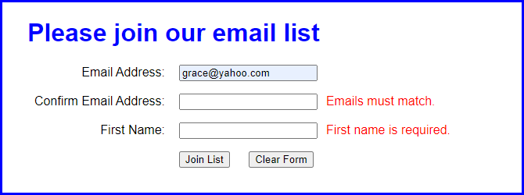

1. Open the application in this folder:

exercises_short\ch01\email_list

1. Start the application, enter an email address in the first text box, and click the Join List button. Note the error messages that are displayed to the right of the other two text boxes.
2. Enter a different email address in the second text box, and enter your name in the third text box. Then, click the Join List button to see what error messages are displayed.
3. Enter valid data in all three text boxes and click the Join List button. Then, note that nothing happens.
4. Use Chrome’s developer tools to locate the statement that caused the error.
5. Use your editor or IDE to fix the error (change *submitt* to *submit*). Then, save your files, and test the application again with valid data. This time, a new page should be displayed when you click the Join List button.

# Short 2-1 Modify the Test Scores application

In this exercise, you’ll modify the Test Scores application so it provides for four test scores and displays the results in a dialog box like the one that follows. Estimated time: 10 to 20 minutes.

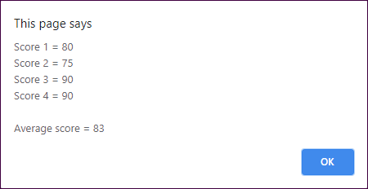

1. Open the application in this folder:

exercises_short\ch02\test_scores

1. Run the application, and note that it works like the one in the book and that it writes the results to the browser page. Then, review the code in the JavaScript file, and note that it’s slightly different than the code in the book, although it gets the same results.
2. Modify the application so it provides for a fourth test score.
3. Modify the application so it displays the results in a dialog box like the one above, as well as in the browser page after the dialog box is closed.

# Short 3-1 Enhance the Future Value application

In this exercise, you’ll make a quick enhancement that shows not only the future value when interest is compounded yearly, but also when it’s compounded monthly. As a result, the display in the browser should look like this:

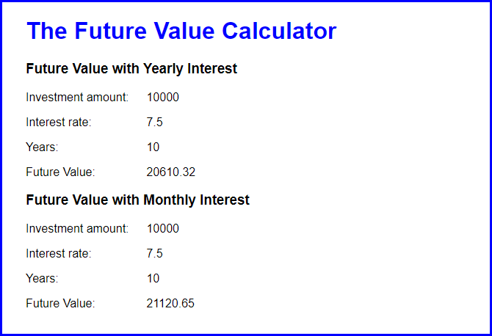

Estimated time: 15 to 20 minutes.

1. Open application in this folder:

exercises_short\ch03\future_value

1. Run the application to make sure it works correctly.
2. Review its code. Note that it is just like the code in the book and that the interest is calculated each year.
3. Add the code for calculating the future value when interest is calculated each month. Then, add the code for displaying the results, as shown above. Be sure to add the heading that identifies each result.
4. ctly.